**PROJECT REPORT TEMPLATE**

1 INTRODUCTION

* 1. Overview

An airplane crash analysis is a detailed investigation into the causes of an aviation accident The goal of an airplane crash analysis is to identify any factors that contributed to the accident, with the ultimate goal of improving safety and preventing future accidents. The process of conducting an airplane crash analysis typically involves the collection and analysis of the wide range of data, including information about the aircraft and its systems, the operators, and any other relevant factors.

This data is typically collected from Kaggle. Once the data has been collected, which may include recommendation for improving safety and preventing accident in the future recommendation may be implemented buy the relevant authorities or industry organization.

Purpose:

It shows the present of fatalities observed due to the cause of the crash and any contributing factors involved in the crash Investigative authorities also provide recommendations for sale operation.

PROBLEM DEFINITION & THINKING

* 1. Empathy map

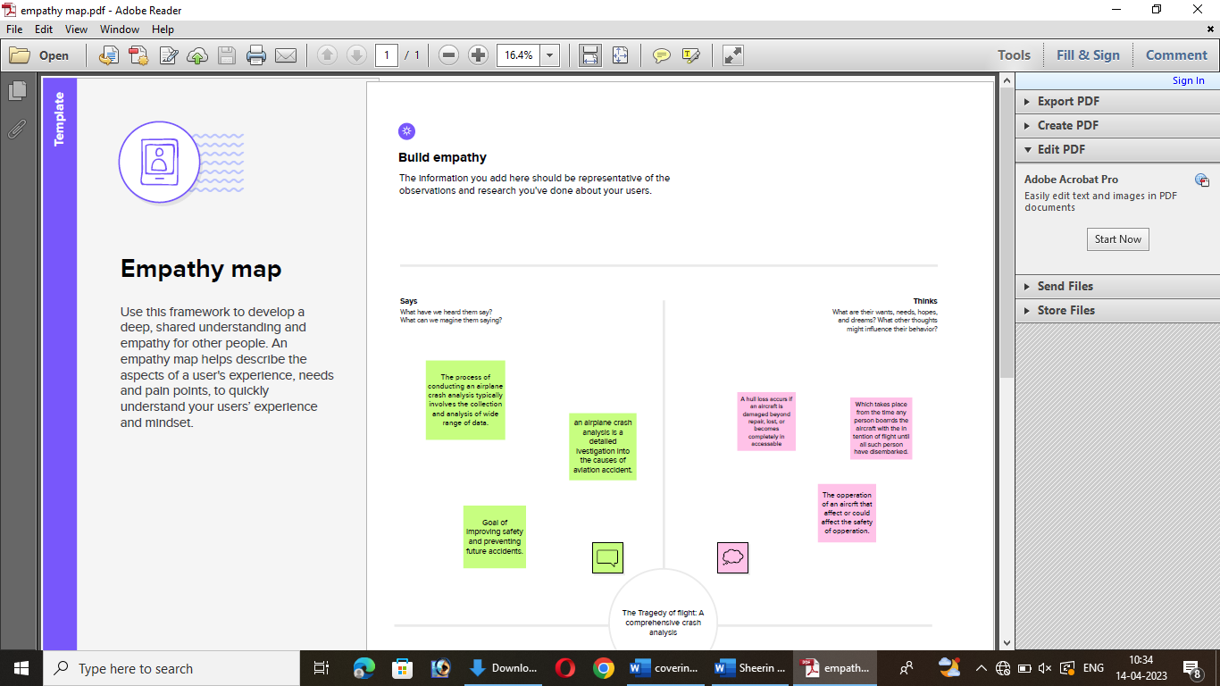

1. RESULT:

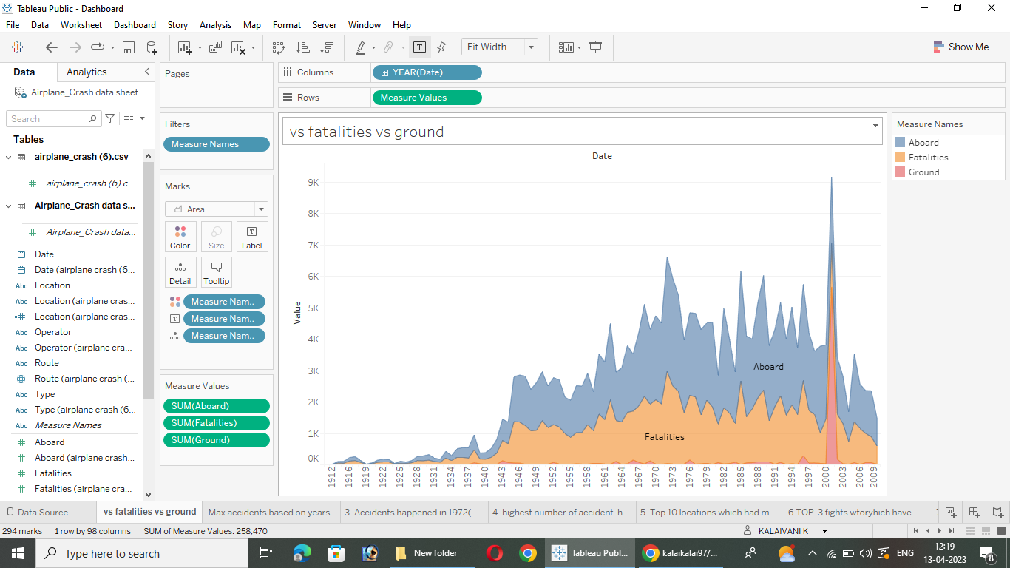

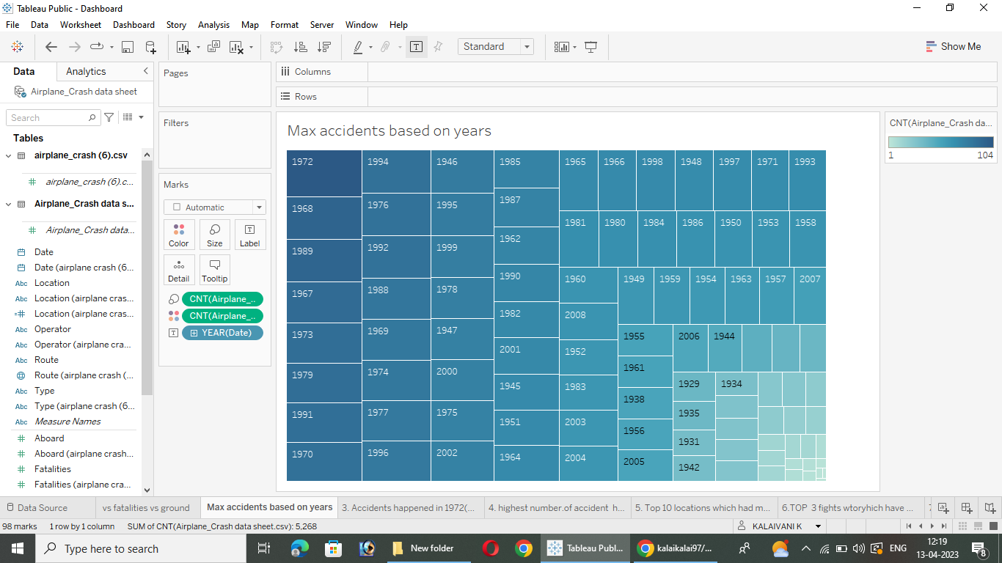

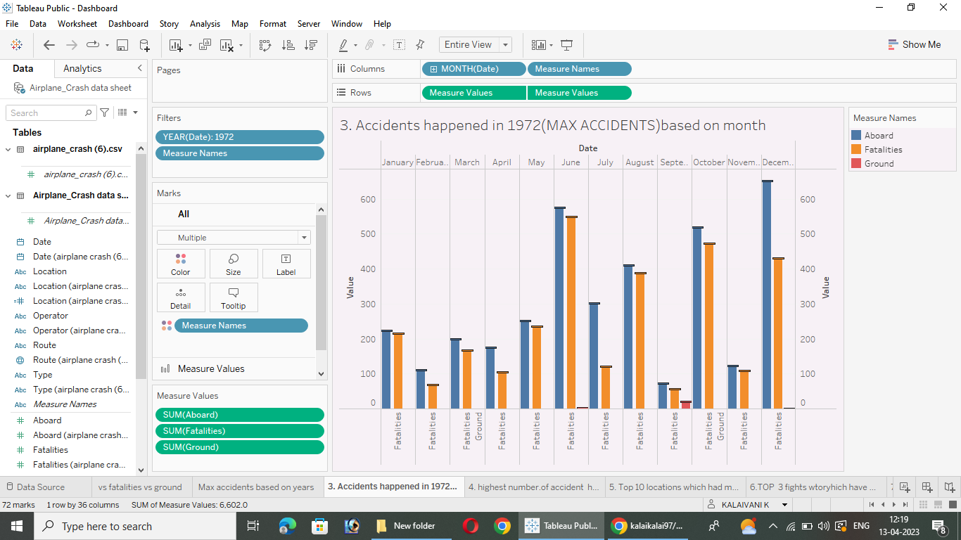

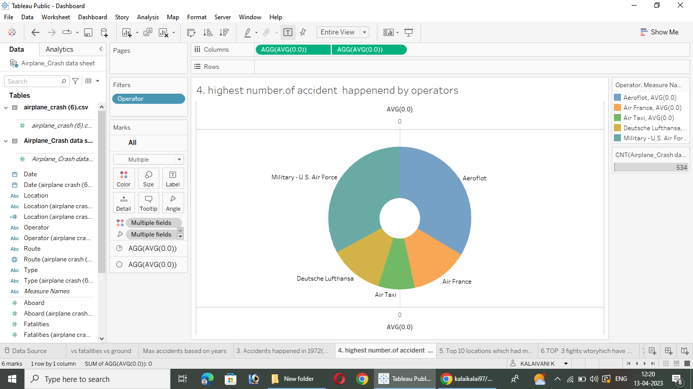

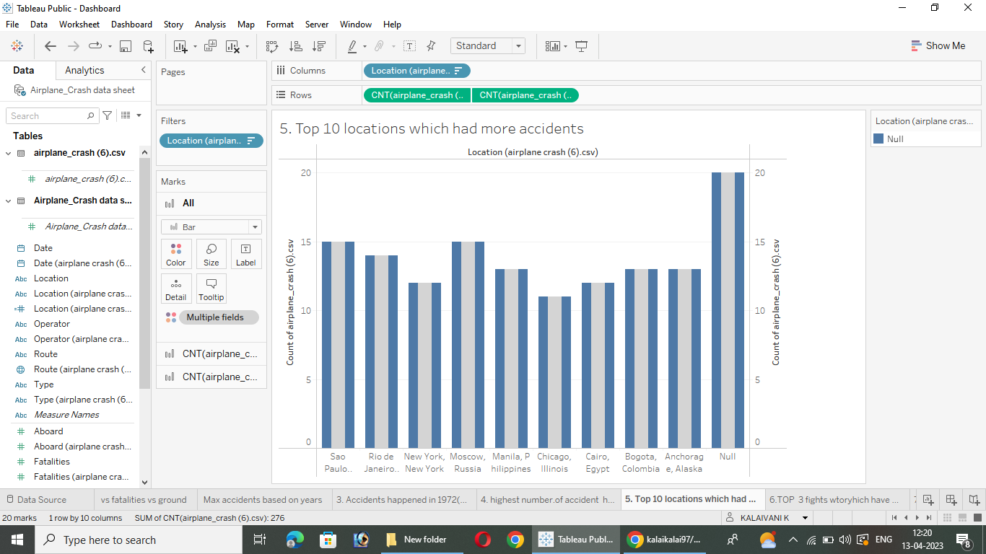

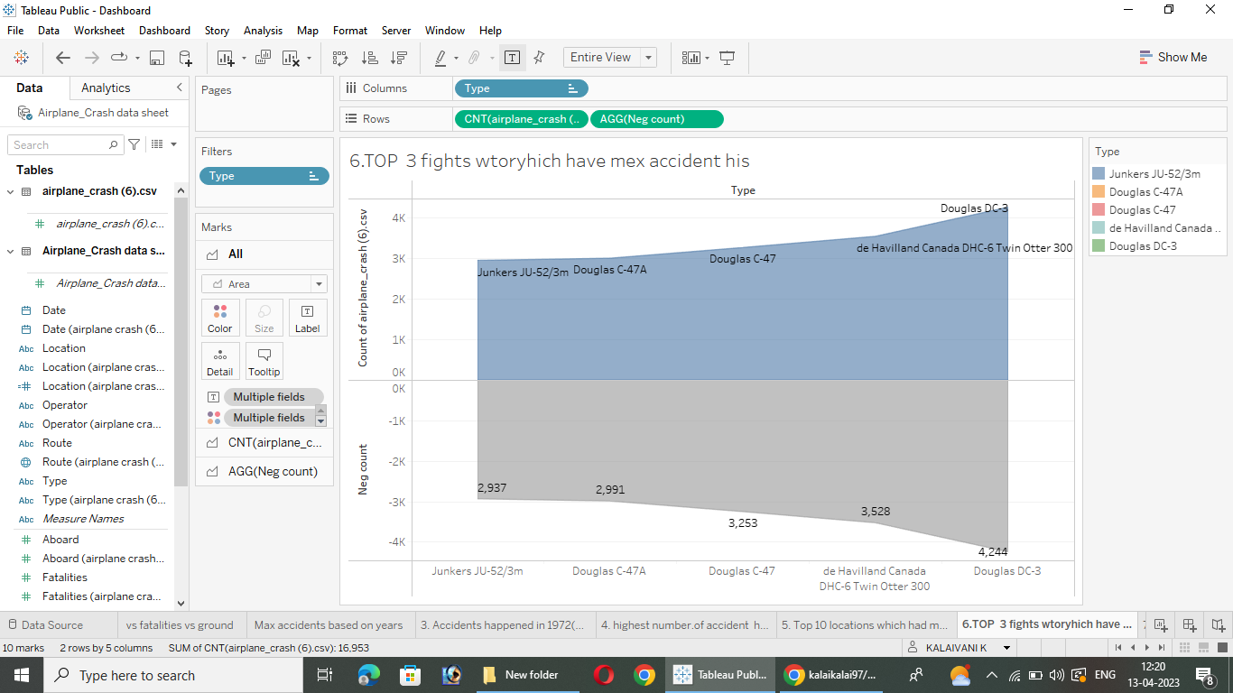

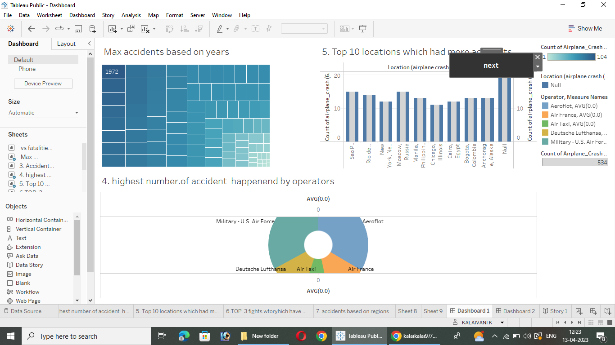

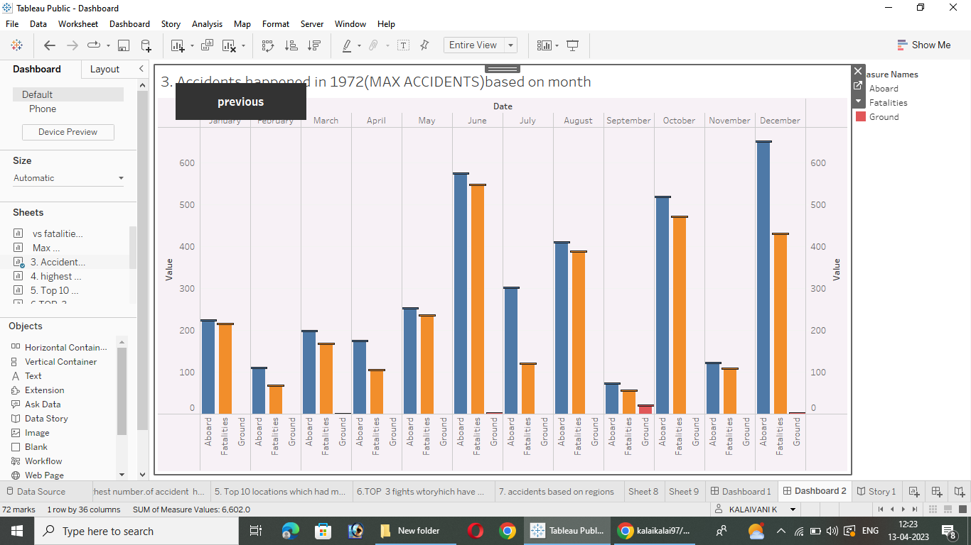

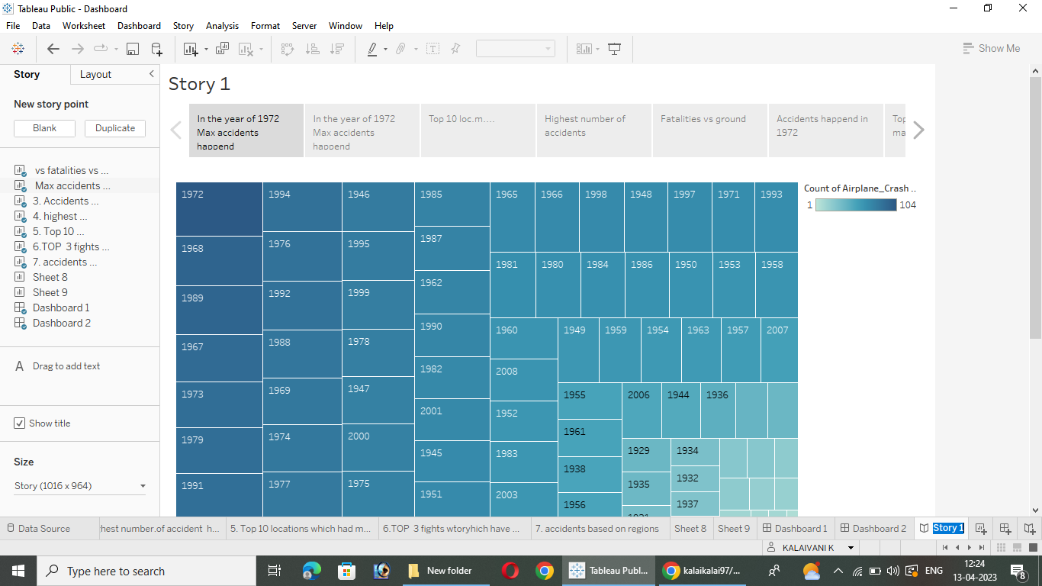

**4. ADVANTAGE**

* Errors can result from ambiguously written procedures, inadequate training, unexpected operational situation or individual judgment.
* This field of study is considered accidents survivability or current standards focus on various system.
* Aircraft record in flight data that can be recovered after an accident.
* Flight track data can be obtained.

**DISADVANTAGE**

* Lack of recent special experience
* There are many causes of aviation accidents.
* Some data only be available for a limited period of time.

**5. CONCLUSION**

* Indian airplane industry was one of the fastest growing airplane Industry across the world during the last decade
* The investigation should include the gathering recording and analysis for all available information the issuance of safety recommendations and the completion for the final report.